User

Manual

Recovery Module

**Version 6.0**

|  |  |
| --- | --- |
| ***Corporate Office*** | ***Offshore Development Center*** |
| *1 Pickering Street*  *#06-03 Great Eastern Centre*  *Singapore 048659* | *Plot # 122 & 123, N.S.E.Z, Phase -2*  *NOIDA, UP 201 305*  *India*  *Tel: 91.11.91.2510483* |

|  |  |  |  |  |
| --- | --- | --- | --- | --- |
| **Author** | | | | |
| **Name** | **Role** | **Date of Preparation** | **Signature** | |
| Varun Gupta | Business Analyst | 30-Jan-2015 | Varun | |
| **Reviewer(s)** | | | | |
| **Name** | **Role** | **Date of Review** | **Signature** | |
| Pravesh Kumar | Manager Projects |  |  | |
|  |  |  |  | |
| **Approver** | | | | |
| **Name** | **Role** | **Date of Approval** | **Signature** | |
| ChengChoon Yip | VP Ebix Exchange  Asia |  |  | |
| **Document Path** | **Version Number** | **Date of Release** | | |
|  | 2.4 | 5 March 2015 | | |
|  | 4.0 | 31st March 2015 | | |
|  | 5.0 | 1 April 2015 | | |
|  | 5.1 | 15 April 2015 | | |
|  | 5.2 | 11 May 2015 | | |
|  | 6.0 |  | | |
| **Revision History** | | | | |
| **Version Number** | **Date of Release** | **Section/ Page # Changed** | | **Details of Changes** |
| 1.0 | 5 March 2015 | Created document for system admin module | | Whole document Created |
| 4.0 | 31st March 2015 | 23 / 115 | | Added upload module |
| 5.0 | 1 April 2015 | Whole document | | Changed sequence of Menus as per actual system admin master sequence. |
| 5.1 | 15 April 2015 | 5.1.4 Select Permission List Screen | | Updated as per latest requirement of security management |
| 5.2 | 11 May 2015 | Section 12, 13 and 28 | | FAL, Common master manual and LOG Request module’s user manual added |
| 6.0 | 1 July 2015 | New Recovery section | | Removed all sections and added Recovery Module |

|  |  |  |
| --- | --- | --- |
| **References** | | |
| **Document** | **Date Received** | **Author** |
|  |  |  |

Contents

1 Recovery Module 4

1.1 Recovery for OD Claim Type 4

1.1.1 Grid Screen 4

1.1.2 Add recovery Screen 5

1.1.2.1 Add recovery fields information 5

1.1.3 OD Grid screen after processed 6

1.1.4 View OD Recovery Screen 7

1.2 Recovery for BI Claim Type 7

1.2.1 Grid Screen 7

1.2.2 Add Recovery screen : 8

1.2.2.1 Field information for BI claim recovery 8

1.2.3 View Recovery Screen 9

# Recovery Module

* **Description:** 
  + Recovery transaction can be performed on recovery tab screen on claim registration menu.
  + Recovery module is applicable for OD and BI type of claims only.
  + For OD claim, user can do recovery after mandate approval of a particular claim.
  + For BI Claim, user can do recovery after payment approval of a particular claim.

## Recovery for OD Claim Type

### Grid Screen for OD claim

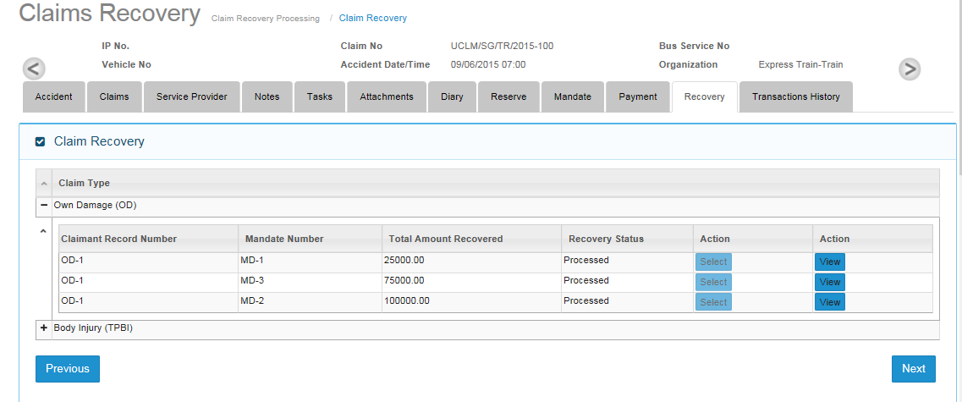

* Grid screen for OD claim will be updated after mandate approval of OD claim.
* Select button click will show Add recovery screen for OD Claim.

### Add recovery Screen

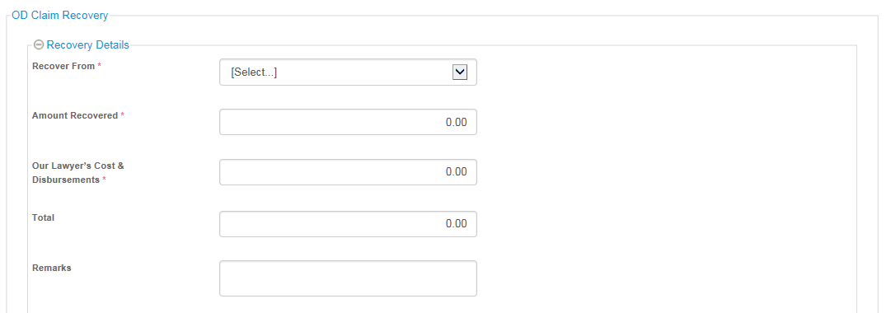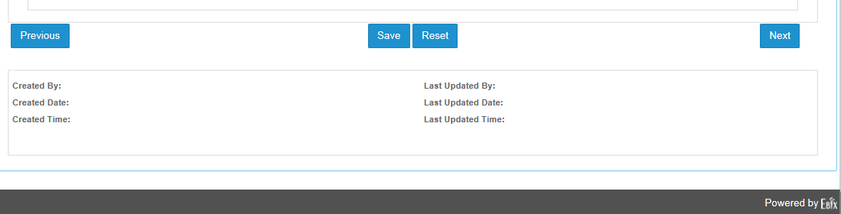

#### Add recovery fields information

|  |  |  |  |  |  |  |
| --- | --- | --- | --- | --- | --- | --- |
| **Field** | **Field Format** | **Field Size** | **Mandatory** | **Non-editable once user land on screen** | **Editable after Saving** | **Remarks** |
| Recover From | Alpha-numeric | 250 Chars | Y | N | N | Data populated from Claimant’s Name and Service Providers created for the OD claim.  Example:  Claimant’s Name = James Tan  Insurer = AXA Insurance  Recover From will have the following input selection for user to choose from:  James Tan  AXA Insurance |
| Remarks | Alpha-numeric | 500 Chars | N | N | Y | Free text field for user to enter comments |
| Amount Recovered | Numeric | 999,999,999.99 | Y | N | Y | Numeric Field for user to enter |
| Our Lawyer’s Cost & Disbursements | Numeric | 999,999,999.99 | Y | N | Y | Numeric Field for user to enter |
| Total | Numeric | 999,999,999.99 | System calculated | Y | N | 1. Total = Amount Recovered + Our Lawyer’s Cost & Disbursements 2. Amount entered is check against the approved mandate. Total amount cannot be less than approved mandate. |

* After clicking on save button, Recovery status will be changed to “Processed” and user then only can view the recovery entry and cannot do any further modifications on that record.

### OD Grid screen after processed

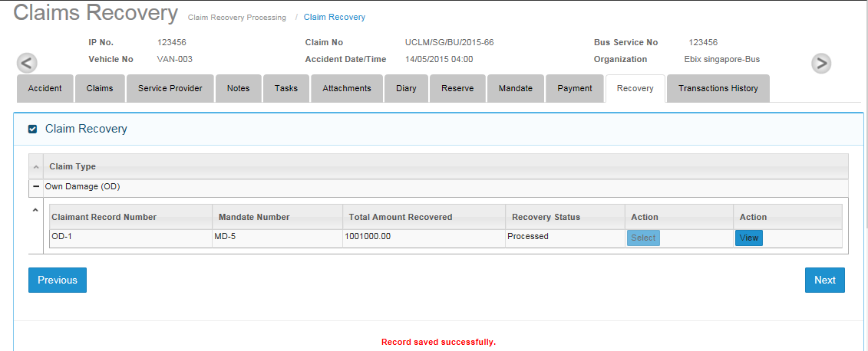

### OD Recovery Screen in View Mode

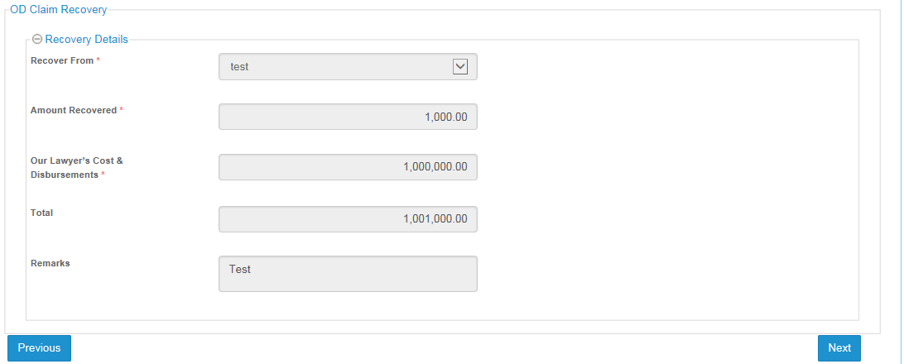

## Recovery for BI Claim Type

* One entry of BI claim type moves to Recovery tab if payment has been approved.

### Grid Screen

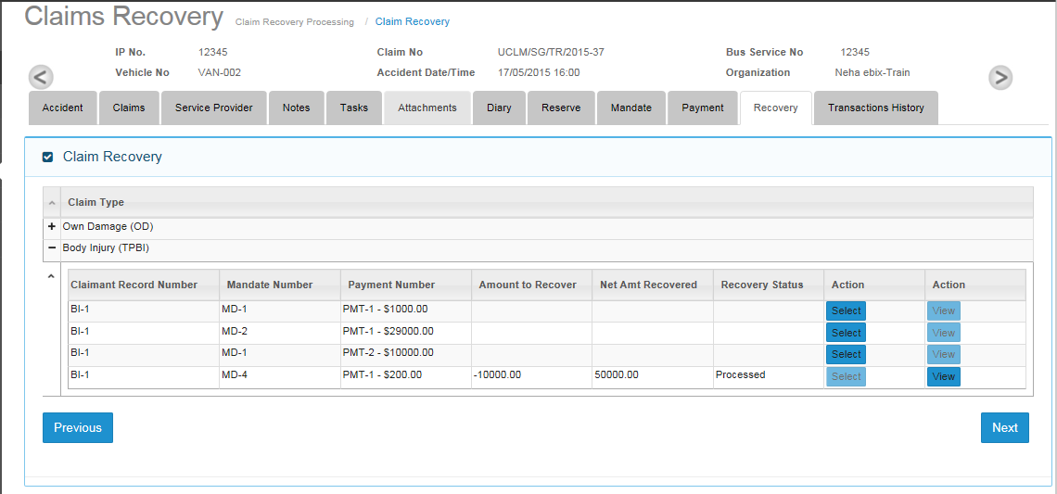

* Whenever payment approve for bi claimant then Recovery Tab grid will be updated for the same record.
* Recovery can be done for BI type of claim in batch for the first time and then for each payment recovery can be done for each new Bi claim payment approval transaction.
* Batch will be formed as per following formula;
  + Total amount of payment for BI claims < Deductible amount

For example:

* + - Deductible is $10000.
    - BI-1 : 5000, BI-2 : 3000, BI-3 : 5000
      * For BI1 and BI2 user will not be able to do recovery as total (5000+3000 = 8000) is less then deductible amount
      * Whenever BI-3 comes in recovery grid , then first batch will be formed because then total of all 3 bi claims will be more then deductible amount.

### Add Recovery screen:

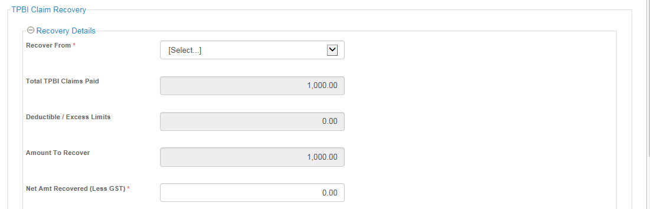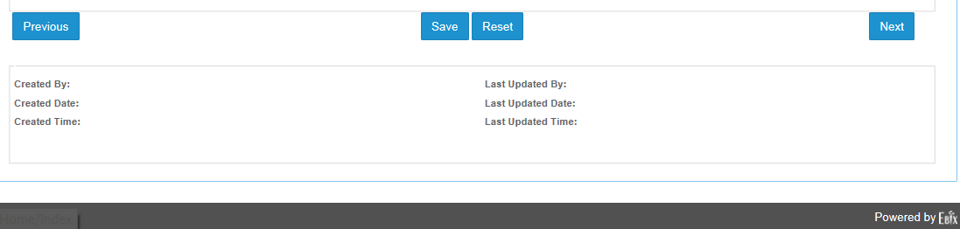

#### Field information for BI claim recovery

|  |  |  |  |  |  |  |
| --- | --- | --- | --- | --- | --- | --- |
| **Field** | **Field Format** | **Field Size** | **Mandatory** | **Non-editable once user land on screen** | **Editable after Saving** | **Remarks** |
| Recover From | Alpha-numeric | 250 Chars | Y | N | N | Data populated from Insurer master table with Insurer type = Own and Both. |
| Total TPBI Claims Paid | Numeric | 999,999,999.99 | System Generated | Y | N | This is pulled from the total values of TPBI Claims Payment |
| Deductible / Excess Limit | Numeric | 999,999,999.99 | System Generated | Y | N | Deductible tagged to the Organization for the Claim that is created will be fetched and displayed in this field |
| Amount to recover | Numeric | 999,999,999.99 | System Generated | Y | N | Value = Total TPBI Payout – Deductible |
| Net Amt Recovered (Less GST) | Numeric | 999,999,999.99 | Y | N | Y | User input. |
| Remarks | Alpha-numeric | 500 Chars | N | N | Y | Default to “Deductible Exceeded” |

### View Recovery Screen

* User can view processed BI claim recovery entry record in non-editable mode by clicking on view button on grid screen.

